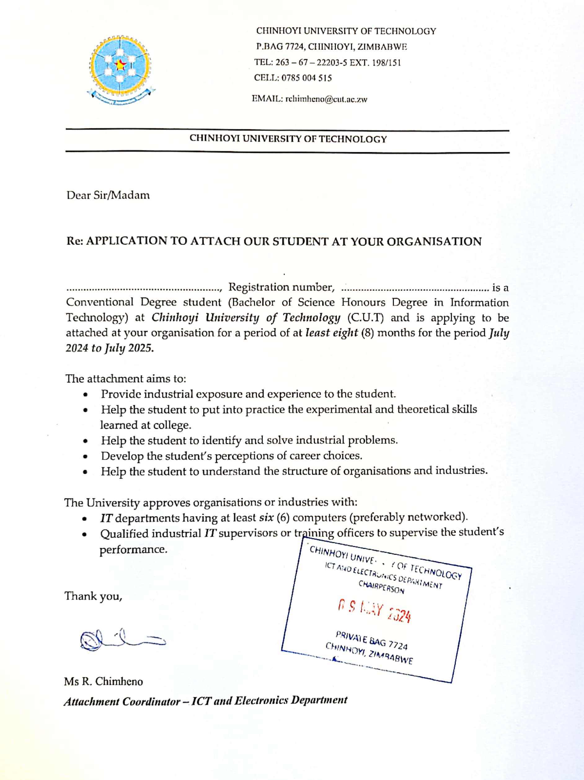

**C22150013C856 876**

**Kupakwashe I Nyanguru856 876**

24 May 2024

The Human Resource Manager

HARARE, Zimbabwe

Dear Sir/Madam

**Re: APPLICATION FOR INDUSTRIAL ATTACHMENT IN INFORMATION TECHNOLOGY**

I hereby forward my curriculum vitae for your consideration

I wish to be considered for the position of INFORMATION TECHNOLOGY (IT) intern available in your organization. As an undergraduate student pursuing a Bachelor’s degree in Information Technology at the Chinhoyi University of Technology, I am eager to gain practical hands-on experience in the IT Department.

I would appreciate the opportunity to discuss this position with you further.

Thank you for your consideration.

Yours Sincerely

Kupakwashe I Nyanguru

+263 781 856 876



**PERSONAL STATEMENT**

**I am a dedicated individual who thrives in new environments. I can work effectively under pressure to meet organizational goals. I am also a team player, which allows me to enhance productivity. I’m also a member of the CUTs Robotics Club known as REST (Robotics Engineering Science Technology).**

**My aim is to extend my skillset during this attachment period and contribute significantly to your company's overall success. Currently pursuing an Honors Degree in Information Technology at the Chinhoyi University of Technology, I am eager to go deeper into the software, hardware, and networking sectors.**

***Kupakwashe Isaac Nyanguru***

’i

**www.linkedin.com/in/**

**kupakwashe-isaac-nyanguru-984994291**

**Skills**

**\*Knowledge in the following programming languages;**

**-Java, C, Python, JavaScript, React JS, Html and CSS.**

**\*Knowledge in the following frameworks and tools;**

**-Git and GitHub, Flutter, React Native.**

**Languages**

**-Shona and English**

**ID No: 63-2298572-F-48**

**Religion: Christian(AFM)**

**Male**

**DATE OF BIRTH : 06/12/2002**

**Chitungwiza, Zengeza 3, No 36 Mahwemashava Rd**

**nyangurukupakwashe@gmail.com**

**0781 856 876**

**Contact Details**

**CHINHOYI UNIVERSITY OF TECHNOLOGY(4 year degree course)**

**EDUCATION : AUGUST 2022-August 2026 till date**

**Bachelor of Science Honours in Information Technology(IT)**

**Module Grading 1.1 to 2.2**

**MODULES GRADES**

**1ST Year Semester 1**

Computer Mathematics versity **of** C

Communication Skills B

Procedural Programming -A

Data Science -A

**1st Year Semester 2**

Visual Languages and Programming -B

Database Management Systems -C

Operating Systems B+

Computer Organization and Architecture C

**2nd Year Semester 1**

Mobile Application Development B+

Website Design and E-Commerce -B

Object Oriented Programming B

Software Engineering and Project Management A+

**2nd Year Semester 2**

Data Structures and Algorithms B

Data Communication and Networks C

Group Project -A

Engineering Research Methods B-

**Technology, I am eager to go deeper into the software, hardware, and networking sectors.**

**O and A level Results**

**-8 O-LEVEL PASSES at ZENGEZA 3 HIGH**

**(2016-2019).**

**-2 A-LEVEL PASSES IN COMPUTER SCIENCE AND BUSINESS STUDIES at ZENGEZA 2 HIGH. (2020-2021)**

**REFERENCE**

Dr F.J.Kiwa R.Chimheno

Lecturer Head of Department – Information Technology

[fjkiwa@cut.ac.zw](mailto:fjkiwa@cut.ac.zw) rchimheno@cut.ac.zw

+263712551386 +263785004515

Chinhoyi University of Technology, Chinhoyi Chinhoyi University of Technology, Chinhoyi

MY DEVELOPER PORTFOLIO LINK = https://kupakwashe-portfolio.netlify.app/